BENEDICTUS JANUARDI – DOCUMENTATION

1. ADD MOVIES

\*Gatau kenapa sending requestnya luama banget.. PAS DI POST tapi udah berhasil ke input di database

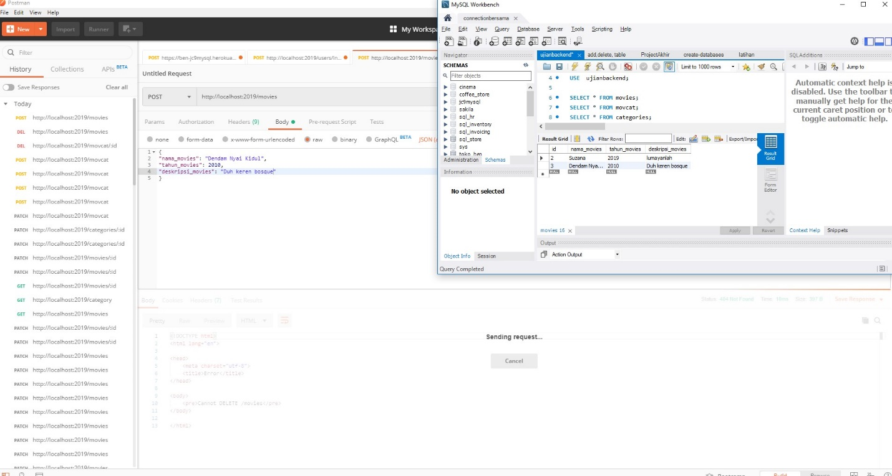

1. SHOW ALL MOVIES

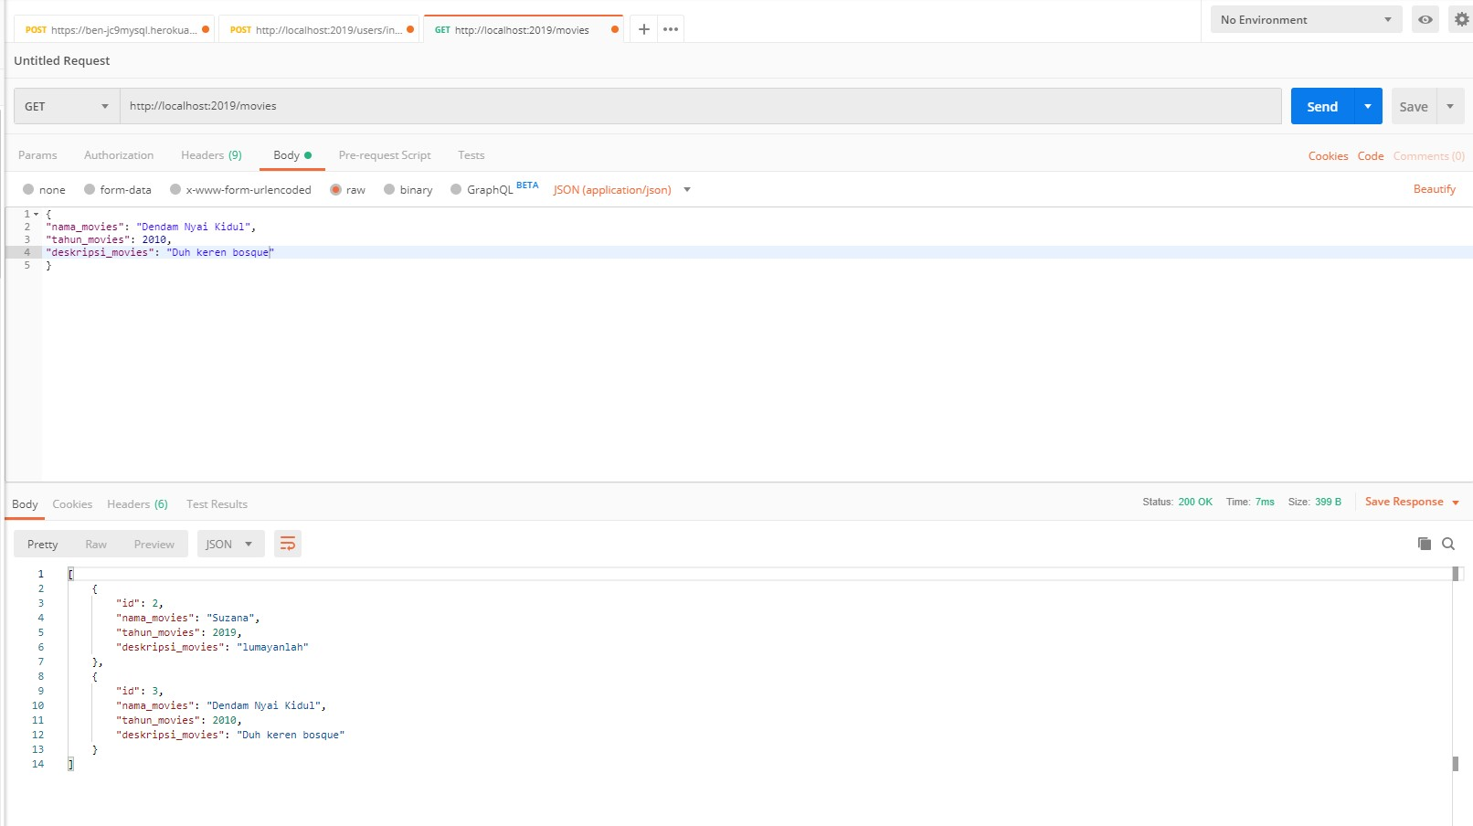

1. DELETE MOVIES

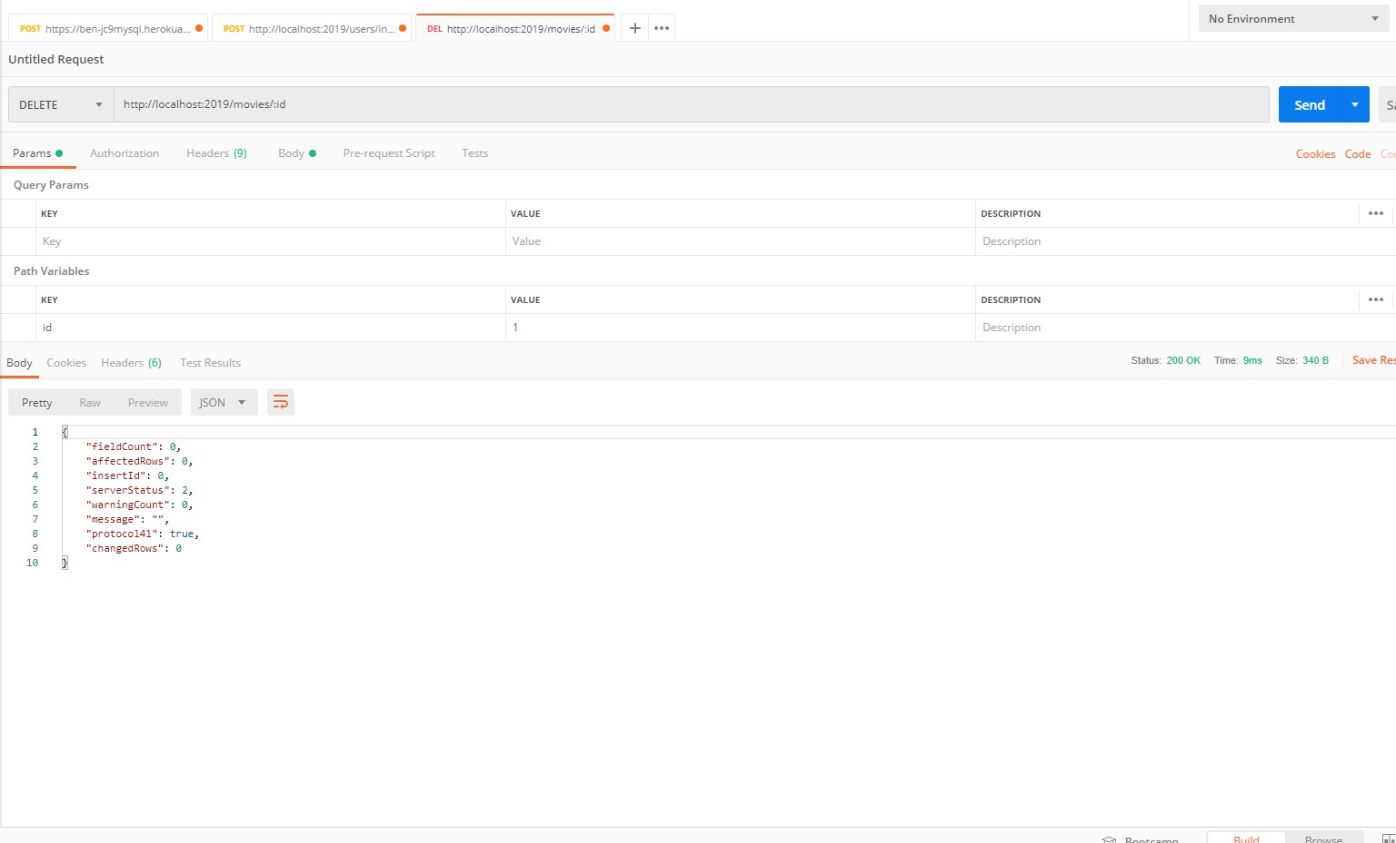

1. EDIT MOVIES

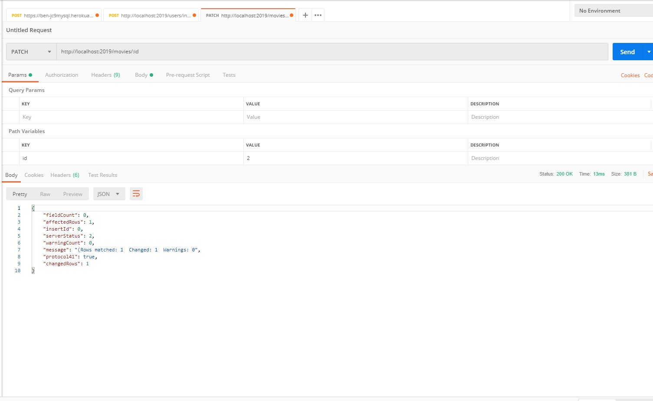

1. ADD CATEGORIES

\*Gatau kenapa sending requestnya luama banget.. PAS DI POST tapi udah berhasil ke input di database

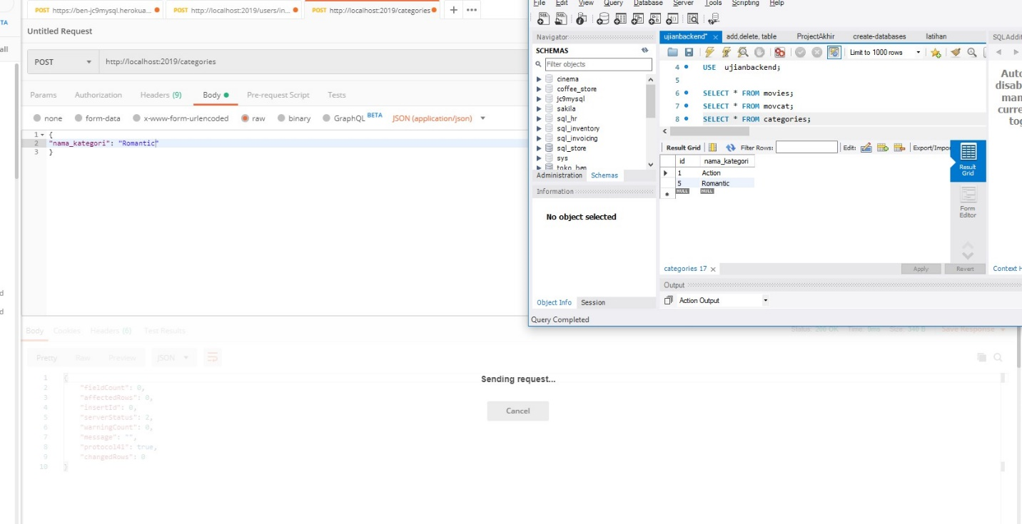

1. SHOW ALL CATEGORIES



1. DELETE CATEGORIES

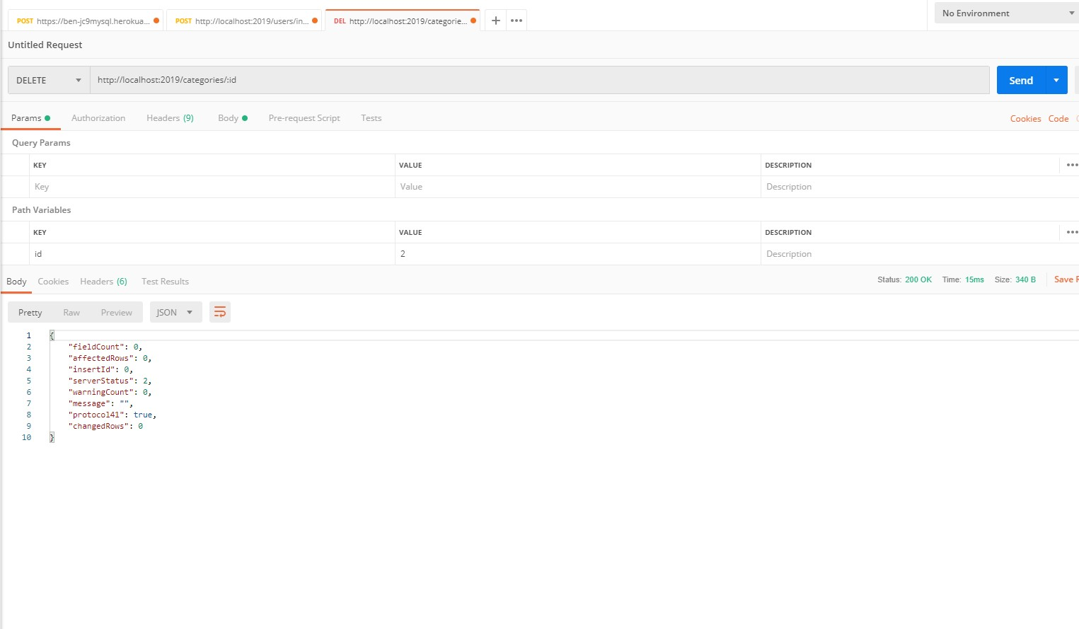

1. EDIT CATEGORIES

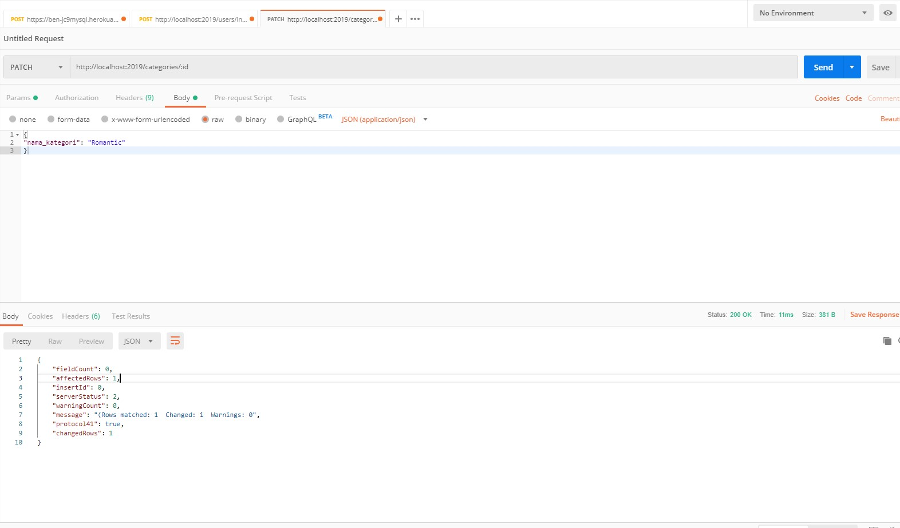

9.ADD MOVCAT

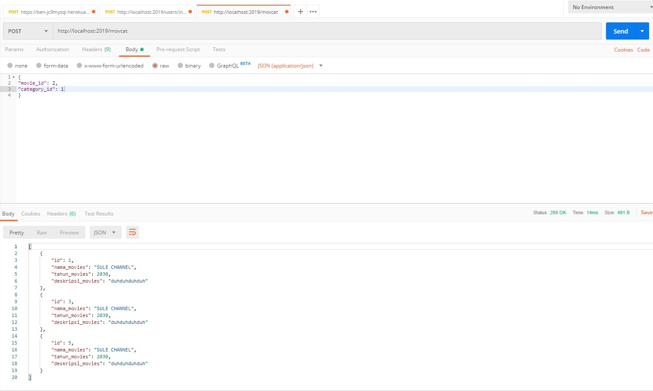

1. DELETE MOVCAT

